

FACULTY OF INFORMATION & COMMUNICATION TECHNOLOGY

SEMESTER 1 SESSION 2020/2021

BITI3533 ARTIFICIAL INTELIGENCE PROJECT MANAGEMENT

FIRE DETECTION USING COMPUTER VISION

LAB 8

PREPARE THE RESPONSIBILITY ASSIGNMENT MATRICES (RAM)

Prepared for:

PROF. TS. DR. GOH ONG SING

Prepared by:

|  |  |  |
| --- | --- | --- |
| **NAME** | **MATRIC NO.** | **PROGRAMME** |
| NUR IZZATI BINTI SHAFIE | B031910476 | BITI |
| NUR’AIN NAJIHA BINTI ZAKARIA | B031910466 | BITI |
| MEGALA D/O SONTULOM | B031910172 | BITI |

10th DECEMBER 2020

1. Prepare the Responsibility Assignment Matrices (RAM) according to for your Artificial Intelligence Project as given in the Table below.

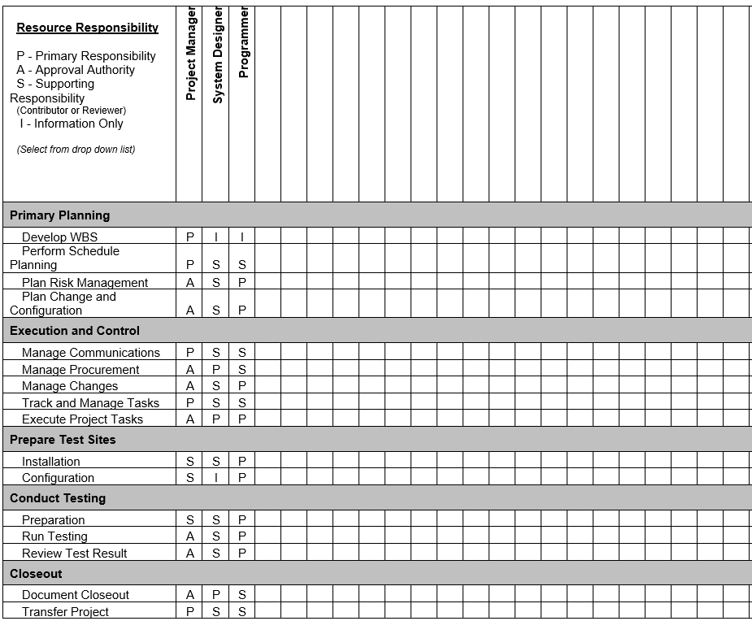

1. Roles and Responsibilities

Describe the specific roles and responsibilities as they have been tailored for AI project. These are not meant to be job descriptions, but rather a summary of the responsibilities for each role. The responsibilities are tailored based on life cycle phase and actual project staffing. It is quite common for multiple roles to be assigned to a single position. The description would list the responsibilities for the functions as being assigned to a single position.

Below is a listing of the most commonly used project roles and responsibilities. Projects should *add/change/delete* the roles as appropriate to your AI project.

1. **Project Manager**

A project manager is a person with the overall responsibility to initiate, plan, design, execute, monitor, control and close a project successfully. The project manager will plan and create the project schedule for the stakeholders and ensure that each phase is implemented, troubleshooting, budget preparation and the process is controlled. The project manager must have the skills to ask pervasive questions, detect unintended assumptions and resolve disputes, and also more general management skills.

1. **System Designer**

The role of the system designer is to develop a comprehensive plan and guidance that can be provided to the programmers. The main input document used by the system designer is the specification of specifications which the system or business analyst that has created. The system designer is also responsible for drafting test schedules and working with a team of users and system testers to ensure that the system is properly tested.

1. **Programmer**

The task of the programmer is to define, develop, install and evaluate a software framework that has designed an algorithm and a system using a convolutionary neural network. When the final development environment has been delivered to the programmer, it can also help maintain and update the software and ensure that the security vulnerabilities are solved and that it operates with new databases. Programmer will build features that allow users to execute simple tasks on a smartphone or computer, while others will develop underlying systems that control networks.